**DataStage**

**How to convert Json data from Google Analytics to a table**

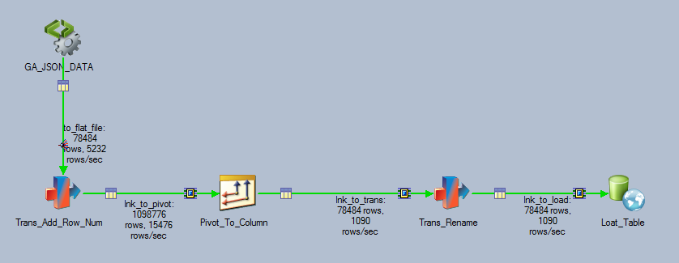

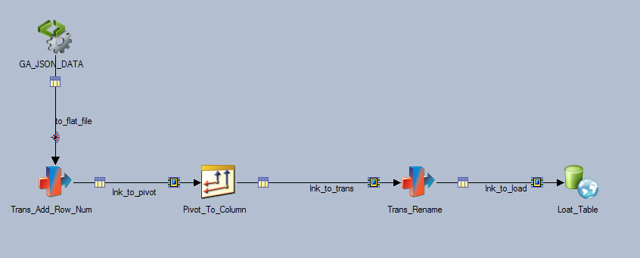

**Introduction**

GA Data obtained as below (see ga_simple_json_export.py). The data will be converted to a table

Start-date = ‘yesterday’

End-date = ‘today’

"metrics": [

"ga:users",

"ga:newusers",

"ga:sessions",

"ga:bounces",

"ga:sessionDuration",

"ga:hits",

"ga:pageviews"

]

"dimensions": "ga:country, ga:region, ga:city, ga:continent, ga:language,ga:date,ga:hour",

1. Configure Hierarchical Data Stage
   1. Open the stage and Click Edit assembly

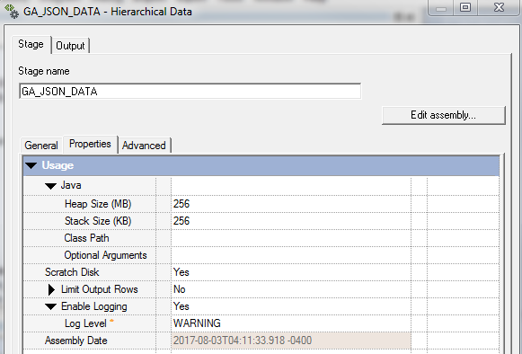

* 1. Click Libraries Tab and create new library and upload an example json file from the desktop.

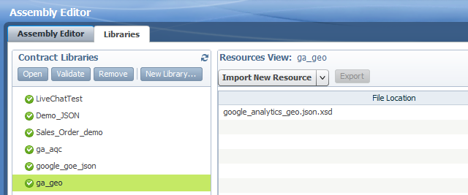

* 1. Click ‘Palette’ and drag JSON_Parser between Input and Output Setup

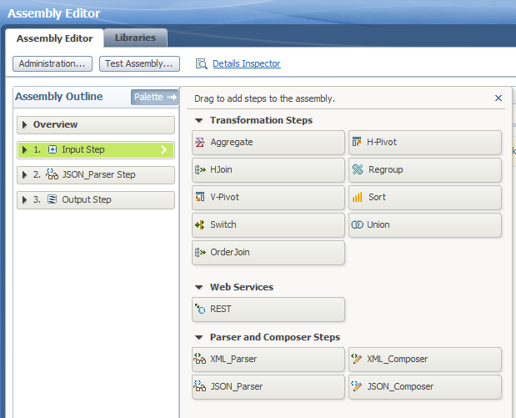

* 1. Input the Source File Path

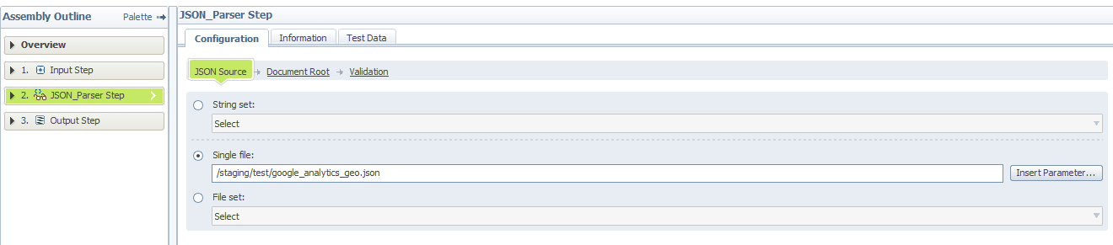

* 1. Select Document Root

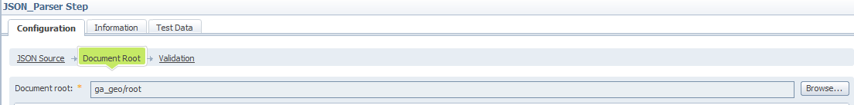

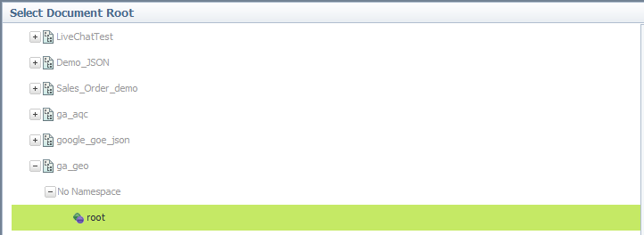

* 1. Set the column as array

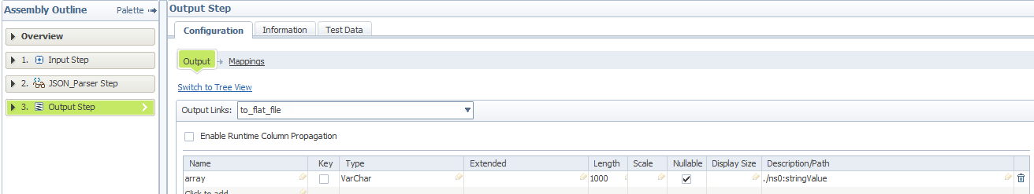

* 1. Map Json value to the column. This is going to be the stringValue in rows

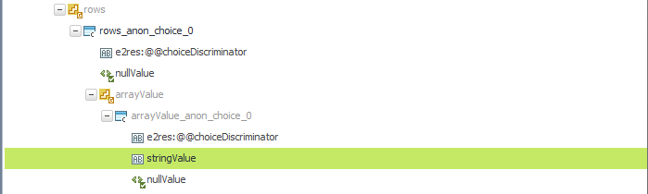

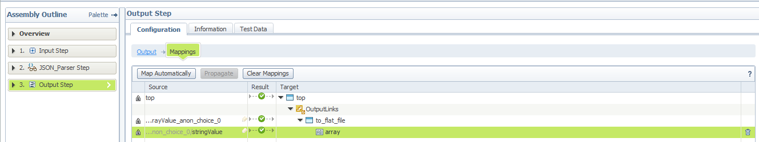

1. Use Looping Condition in Transformer Stage and add @Iteration as column_count

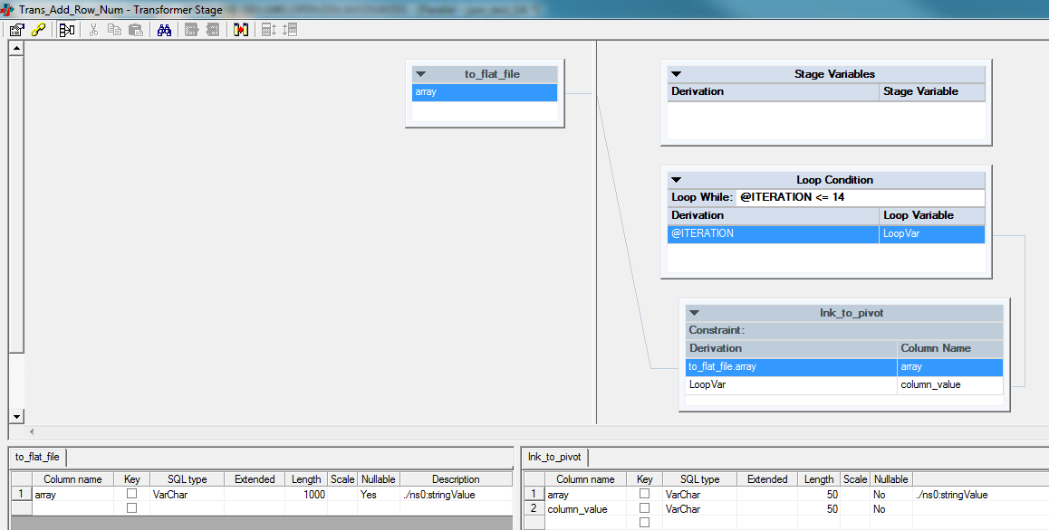

1. Do Vertical Pivot by using Enterprise Pivot Stage

3-1. Set Pivot Type = Vertical

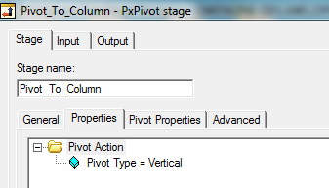

3-2. Set Array Size to 14 and Pivot the column, array, grouping by the column, column_value.

1. Rename Column and Data Type.

In Transformer stage, varchar to Integer conversion can be done without function. We used StringToDate() function to convert the Date column to the Date data type.

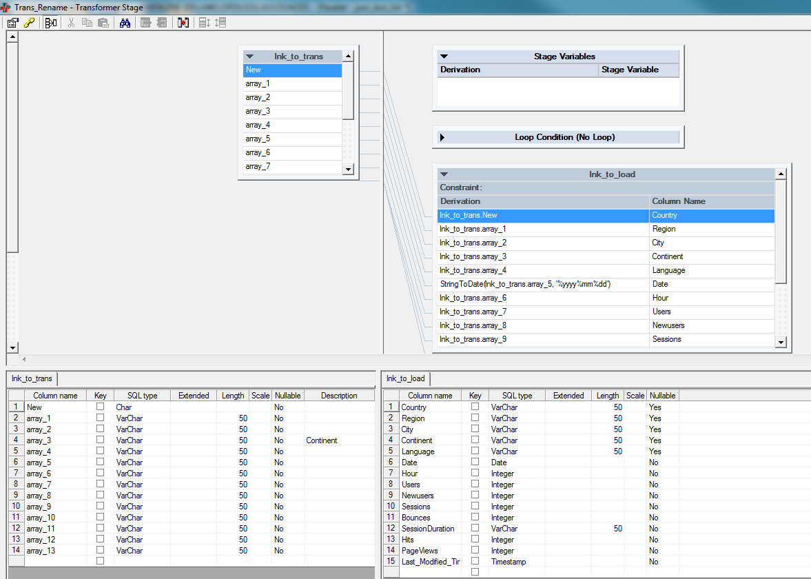

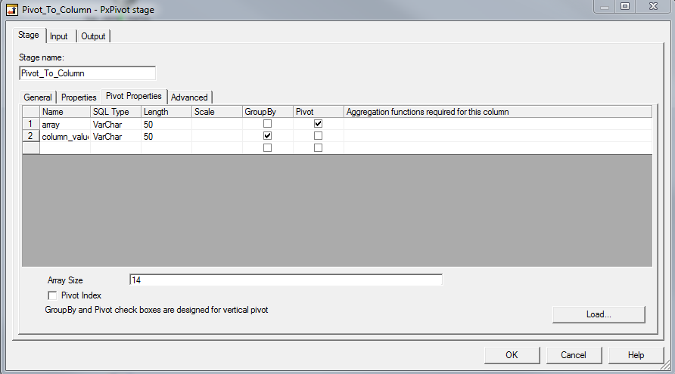

1. Load to Table

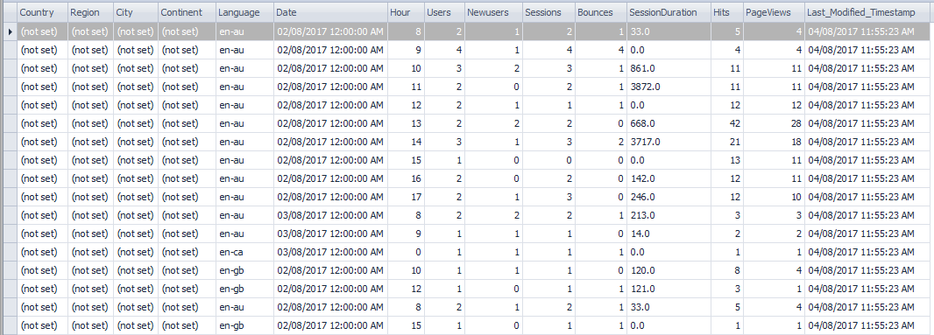

**How to convert nested Json structure into a table**

In DataStage, we can convert complex nested JSON into a flat table. We convert the JSON structure below to a table structure.



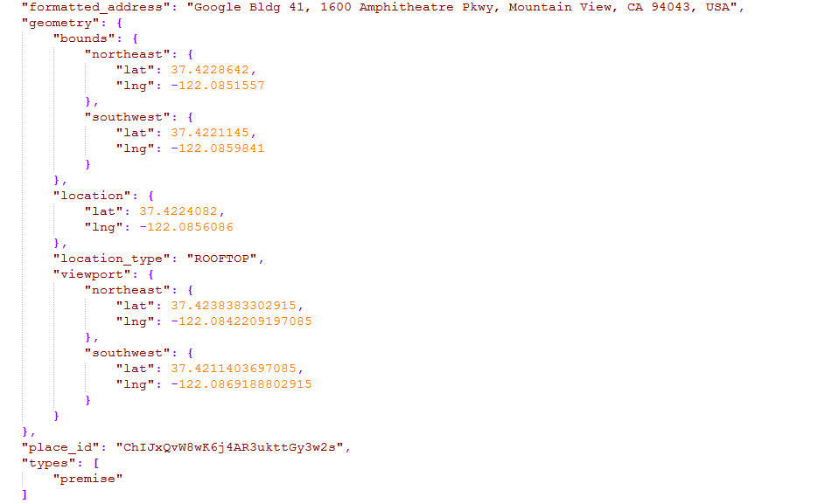

1. Configure Hierarchical Data Stage
   1. Open the stage and click Edit assembly.

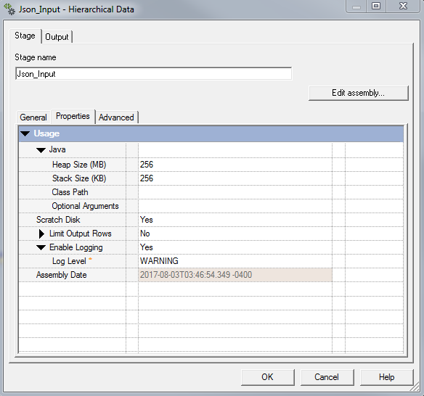

* 1. Go to the Libraries tab and add a new library. Then import the Json file.

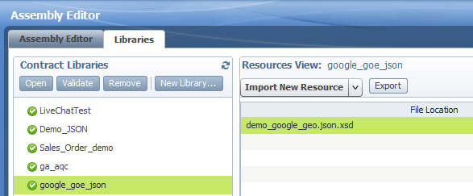

* 1. Click Palette and add JSON Parser between input and output stages

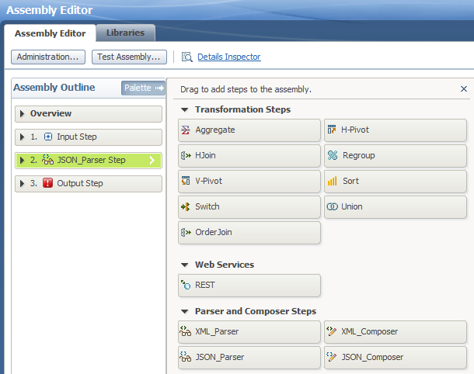

* 1. Select the file path for JSON Source

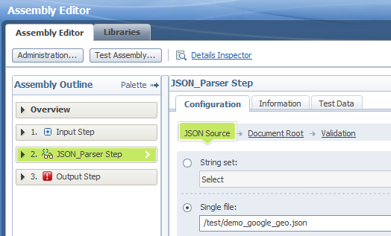

* 1. Choose document root from the library we just created.

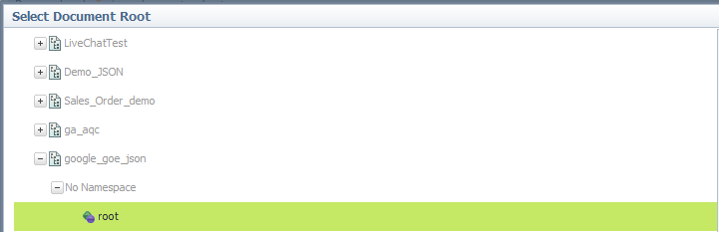

1-6. In the Output, define the column name and type.

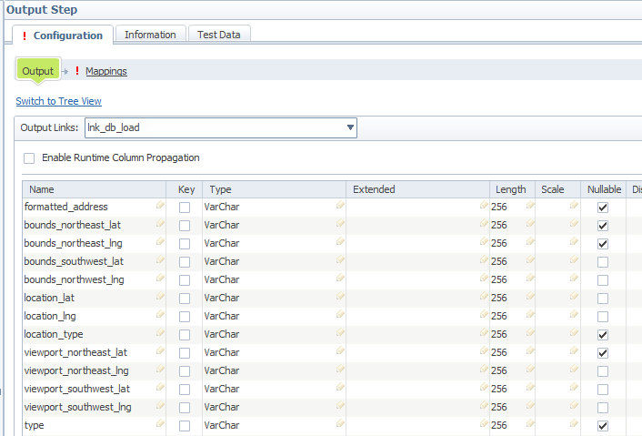

* 1. Mapping

As parent node, map below for lnk_db_load

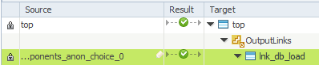

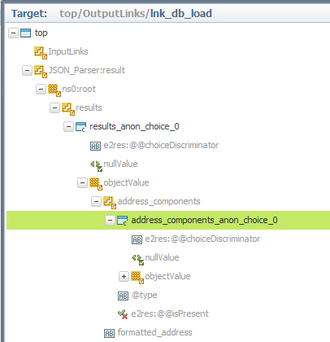

Formatted_Adress

Bounds_northeast_lat

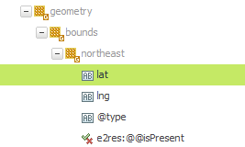

To map type, go back to lnk_db_load and choose a new parent node.

Otherwise you will get the error below.

**CDIUI2820E The mapping is not applicable to do an invalid type coversion or difference in the source and target list dimensions.**

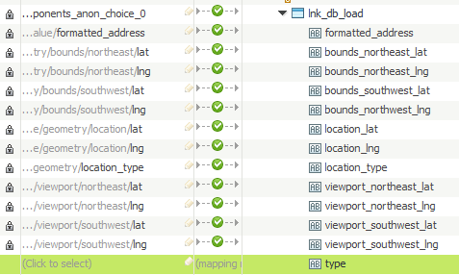

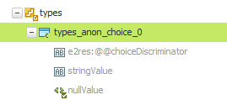

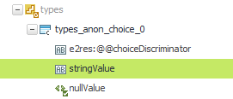

Once mapping is completed, press OK

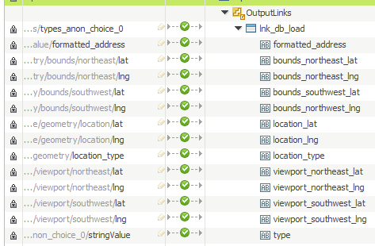

Connect to a db load stage and load the data

